1. **PROJECT TITLE**

*\*your project title here*

1. **INTRODUCTION**

**\****(discuss here the context of the project, background, client, business process, problems with current system and the solution). Also, cite and discuss here the interview with your client*

*Example:*

In this generation, modern technology is the most powerful and popular thing. Computers have become part of the life for accessing almost any kind of information. One main purpose of the computer is for business, school and other companies or organization. Computerization is a control system that manages processes in industrial workplace. Reduced human error and processing time. According to Halfacre (2010) many establishment like restaurant adopted the computerization because it produce accurate and reliable information compare to a manual process. Technology helps to make the work presentable and task done in a short period of time. Due to the advancement of technology, it is now broadly influences the business transaction. The adaption of technology and emergence of devices has led to the automation in the hospitality industry. Business in hospitality industry such as restaurant can be improved with the used of technologies. Using computer based system in a restaurant helps to make the customer satisfied to the overall performance of the service because of the fastest service experience of the customer. Today, the competition in the restaurant business is continuously growing and has increased in many food ordering techniques.

Zark’s BF Homes in Parañaque used manual process of ordering, billing, issuing of receipt and even in inventory of sales. When taking orders of customers, the crew listed it on a piece of paper and hand it over directly to the cashier and chef. According to the manager and some employee they have a time that the ordered list of the customer was lost and lead to repeatable task of taking the order at the same customer. After the employee take the order of the customer, the crew will give the order list manually to the chef and cashier. In process, it takes time before the customer’s have their orders. In terms of billing, the customer call the crew to compute the total bill, then the crew will go to the cashier and compute the customer’s bill by the used of calculator, the crew gives the total bill of the customer by means of ready-made receipt paper. The customer will pay the bill and the crew will go back to the cashier if the customer has a change and also to mark the receipt for confirm that it is already paid. The details of the bills were listed down to their sales book for the records of transaction before giving it back to the customer. In every management there is different inventory process. While in the Zark’s Bf homes Paranaque they have a simple process of inventory. They inventory the main ingredients in every menu, they don’t make an inventory on the additives like the salt or ketchup they called it served as use they have the accurate number of grams in every week, also the utensils and straw are not being part of the inventory process, but at every end of the day, the inventory of the sales and stocks is done by the manager. Computing the total sales of the restaurant and determining the most demand menu is done every end of the day. The assigned manager checks all the stocks that are needed to be refilled. In checking the transaction records, the manager manually tally and compute the total sales on that day. The burger shop only uses record book, pen and filing cabinets for records keeping.

Lan-Based Ordering with Billing System and Inventory of Sales, will be a very good solution for the Zark’s Burger Bf homes for a better management of transaction. These serve as a helpful tool to lessen the human error encounter in manual process and minimize the time consumed in each transactions.

1. **SYSTEM CONCEPT AND REQUIREMENTS**

*\* discuss here the scope and limitation of your system, features, etc.*

*\* Cite your and discuss your ERD and Normalization here.*

1. **SYSTEM DESIGN SPECIFICATION AND CODING**

***\*****discuss here first your development process including the development tools (PL,Database, etc) used.*

***\*****insert all your system screenshot and provide a description in each figure.*

*Example:*

*The Splash form or the Loading form allowed the user to see the short information about the system. Figure 3 showed the screen layout of Splash form or Loading form.*

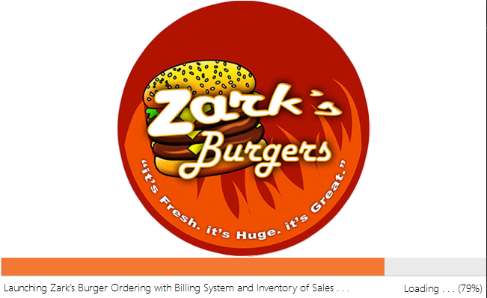

*Figure 3. Screen Layout of Splash or Loading form*

1. **SUPPORTING DOCUMENTS**

*\*insert here all your supporting documents such as the client approval letter, interview reports, ERD, normalization, photo documentation, etc.*

1. **REFERENCES**

*\*insert here all books, journals, website references*

*Example:*

***Thesis and Dissertations***

*Adem.,Galacgac.,and Tubale. (2013) Rental and Inventory of Torres Catering Services.*

*Undergraduate Thesis of Mapua Institute Technology.*

***Online Sources***

*Obeten., Abel. Restaurant Management Information System. (2010) Retrieved from: https://publications.theseus.fi/bitstream/handle/Thesis.pdf*

**Submitted by:**

**Submitted to:**

**KHWEEN PRINCES H. MONCAYO**

Instructor